**The Influence of Crime Types and Location Categories on Victimizations Across Regions in New Zealand**

This study explores how do different crime types and location types influence the number of victimizations across different regions in New Zealand. The 68 territorial authorities were grouped into 18 regions based on New Zealand’s national geographic division. Sixteen of these regions are officially regional areas of New Zealand, and some outlying island areas are not within the regional boundaries. These outlying island areas are named Chatham Islands and Area Outside. Additionally, the 32 location types were grouped into seven groups based on the attributes of the location type. For example, all types related to Dewelling were classified as residential because they are all related to residential.

Figure 1 shows the number of victimizations vary seven location types across 18 regions in New Zealand. These location types are Industrial, Agricultural, Community/Public Services, Transport, Commercial, Residential, and Other. The subfigures, labelled 1a to 1r, represent each region and are arranged according to the total number of victimizations recorded. Figure 1a shows Auckland has the highest number of victimizations, especially in residential and commercial areas, with numbers reaching over 300K and 200K, respectively. The Canterbury, Waikato and Wellington regions also have a high number of victimizations but at a significantly lower rate than Auckland. Smaller regions like Gisborne, West Coast, Chatham Islands, and Tasman (Figures 1i, 1q, 1r, 1p) report significantly lower number of victimizations.

Some location types consistently show higher number of victimizations across most regions in New Zealand. Residential and commercial areas account for a large proportion of victimizations in the regions which exclude Taranaki, West Coast, Chatham Islands and Area Outside. Transport and community/public services locations have higher number of victimizations across urbanized regions like Auckland, Canterbury and Wellington than that of other regions.

Theft and Related Offences and Unlawful Entry with Intent/Burglary are the most frequent crime types across all regions, especially in residential and commercial location type. Acts Intended to Cause Injury and Abduction, Harassment, and Related Offences are less common across most regions and are mainly distributed across public services and community spaces. Sexual Assault and Related Offences appear more frequently in residential location type. Other crime types appear less common across all location types in each region in New Zealand.

Overall, Auckland shows the highest number of victimizations, especially in residential and commercial location types which dominated by theft and unlawful entry crimes. Wellington, Canterbury, and Waikato shows a similar pattern, though at a lower scale. These regions have similar crime type with a focus on theft and unlawful entry. Chatham Islands, Tasman, Gisborne, West Coast, and other small or rural regions show lower number of victimizations across all crime types and location types. This could indicate that lower population densities and reduced commercial activity correspond to fewer opportunities for certain types of crime, such as theft or robbery.

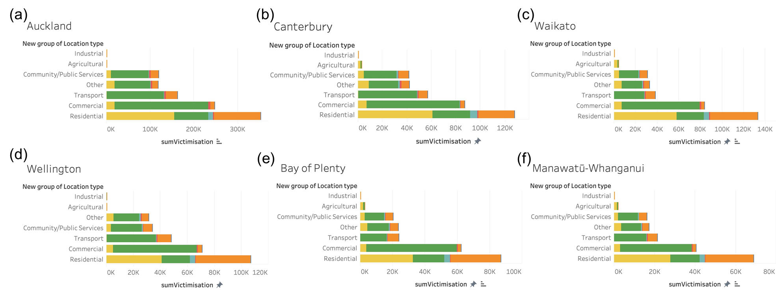

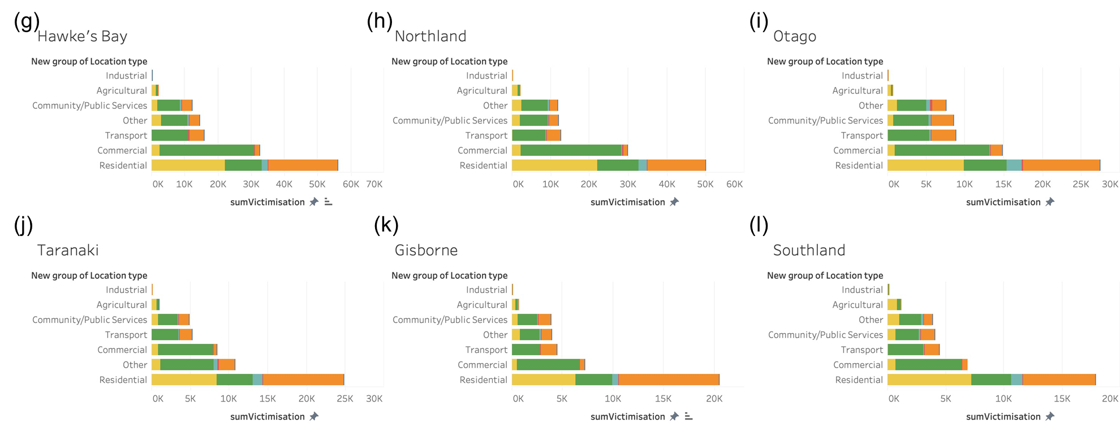

图形用户界面, 文本, 应用程序

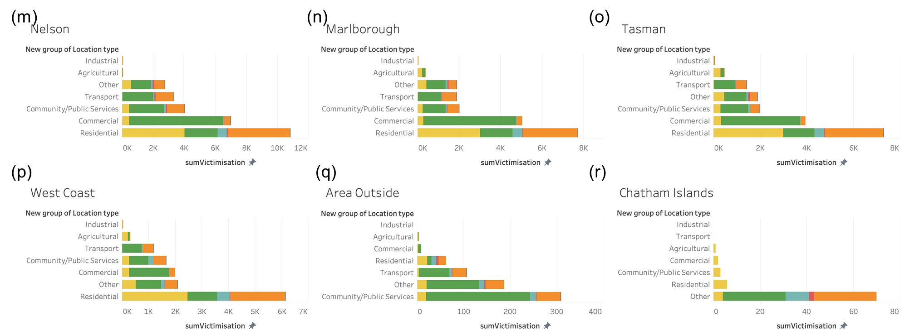

Figure 1: The number of victimizations vary seven location types across 18 regions in New Zealand